**The Human Side of Logistics**

**TEACHING NOTE**

**Critical Incident Overview**

This incident is a decision case where Robert Stevens, a fresh college graduate who was recently hired to an entry-level position at an aircraft manufacturer, finds himself embroiled in a conflict involving three offices. Robert’s branch (the Newark office of a multinational company, Lucas Aeronautics) is being blamed for a number of logistics problems, including damaged cargo received by the warehouse in Tampa Bay. Given Robert’s junior position in the logistics group, he is worried that he will become the scapegoat. He has repeatedly expressed his concerns about the packaging procedures used to secure the shipments that are mandated by headquarters in Omaha. However, he now faces a teleconference with senior management from Tampa Bay and Omaha, and needs to decide how to handle the call. If he fails to resolve this conflict, he may find himself without a job.

This critical incident is focused on the topic of conflict resolution in an organization where one has little to no power. Students are asked to place themselves in Robert’s position, and make a decision on how to handle the conflict.

This incident can be used to teach conflict resolution in the absence of positional power. It can also be used to illustrate how to communicate the need for change from the bottom up within an organization. This decision case was predominantly written for a Negotiations or Conflict Resolution course, but could also be used in Organizational Behavior and Human Resources courses. It is also suitable for general Principles of Management courses.

**Research Methods**

This critical incident was written based on field research, including communications with the student and company. The names of the individuals and the company have been disguised in the interest of anonymity. In addition, a literature review of the theories was conducted to support the teaching note with appropriate theoretical frameworks.

**Learning Objectives**

The Learning Objectives for students from this critical incident are to:

1. Comprehend the managerial issues created by geographical distance and consequences for conflict resolution.
2. Analyze and apply the Dual Concern Model for Conflict resolution in an organizational setting. Understand the difference between approaching conflict as a zero-sum versus a non-zero-sum situation.
3. Evaluate the appropriate conflict resolution strategies, and synthesize the possible solutions.
4. Apply the theoretical framework of moving from positions to interests to resolving an intra-organizational conflict. Specifically, analyze how a lower-level employee can manage a conflict with higher-level employees and create a win-win situation for all.

**Questions**

1. Describe the Dual Concern Model of Conflict Resolution? Apply it to the situation faced by Robert Stevens.
2. Conflicts can be approached as being Zero-Sum or non-Zero-Sum. How do the two approaches differ from each other? Which approach is best for Robert?
3. Assume that management was willing to listen to Robert’s ideas. What basic conflict resolution strategy should Robert use when presenting his proposals and recommended changes in the teleconference?
4. How does Robert approach the teleconference knowing that Headquarters is under the impression that his facility is at fault? Building on your answer to Question 3, what are some suggestions he should make, and how should he approach his seniors?

**Answers**

1. **Describe the Dual Concern Model of Conflict Resolution? Apply it to the situation faced by Robert Stevens.**

People respond to conflict based on different combinations of two underlying motives: the motive to be assertive (or concern for oneself) and the motive to be cooperative (or the concern for others). The Dual Concern framework brings links these motives together to arrive at five possible approaches for Conflict Resolution as shown in the diagram below (Rahim, 2002).

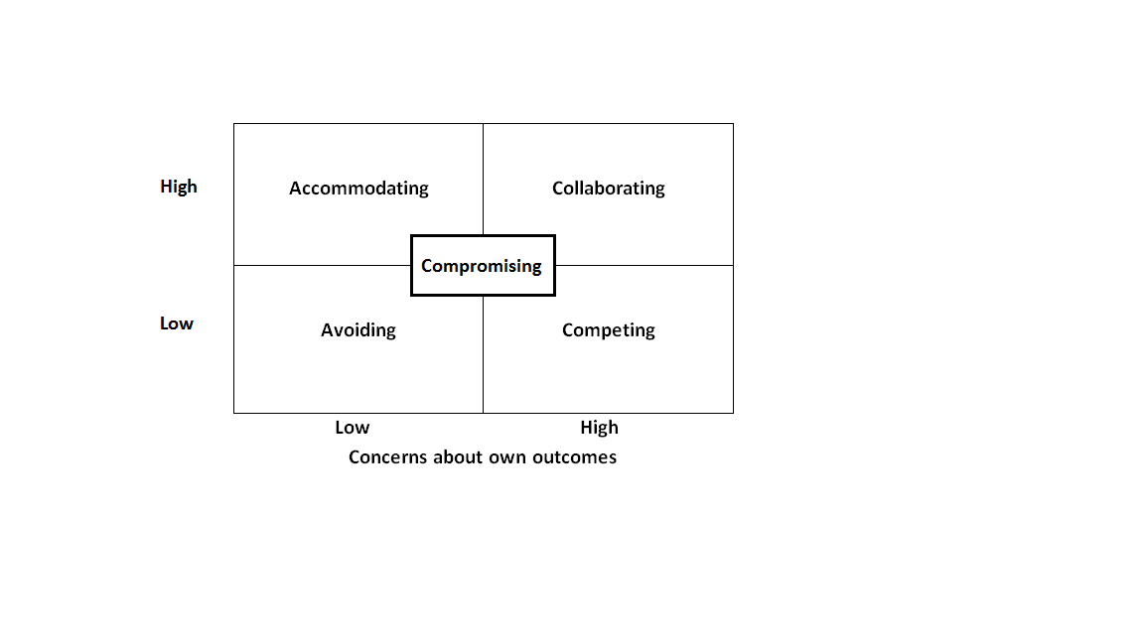Figure TN-1

Robert’s supervisor in Newark is using “Avoidance” as his strategy. He acknowledges the points Robert makes in his arguments, but is unwilling to bring them up with either the warehouse manager in Tampa Bay or anyone at headquarters in Omaha, Nebraska. He is low on both concern for his own outcomes and the outcomes of others.

The warehouse manager in Tampa Bay is high on concern about his own outcomes and thus is unwilling to incur additional costs to make unloading safer. He would rather blame Newark for the damage and let them deal with it. His strategy is to be “Competitive”.

Headquarters in Omaha has a reputation for being open to ideas, but so far they have only heard complaints from Tampa Bay about the damaged shipments from Newark. It is unclear whether anything Robert has told the load planners in Omaha has been communicated to management, thus we cannot identify which strategy is being used by Omaha at this time. Their openness to new ideas suggests that they would be willing to be “Collaborative”.

Robert has so far been concerned about keeping the load planners happy, and has done what he can to minimize damages in shipments to Tampa Bay. He is high in his concern for others, but low in his concern for his own outcomes. In the past, his strategy has been to be “Accommodating”. This has not worked out well for Robert and he needs to consider changing his strategy.

1. **Conflicts can be approached as being Zero-sum or Non Zero-sum. How do the two approaches differ from each other? Which approach is best for Robert?**

Zero-sum refers to approaching a situation where one participant can only gain if the other loses an equal amount (Camerer, 1997). For example, if two people were sharing a pie and the first person took two-thirds, then the second person would only have one-third. If the second person wanted more, then the first person would have to give some up. Here one can only gain by taking away from another. Zero-sum is also referred to as a competitive or win-lose approach (Lewicki, Barry & Saunders, 2011) because it in order for one to win, someone else has to lose.

Non zero-sum situations differ from zero-sum ones in that they are not strictly competitive. This approach assumes the presence of both cooperative and competitive elements and is also called the win-win approach or a collaborative approach. One person does not have to lose in order for the other to gain. Thus, this approach can be thought of as taking a problem-solving or collaborative approach.

Some situations are truly zero-sum, but many, like the conflict described in this case, can be approached with a zero-sum perspective even when they are not necessarily zero-sum conflicts. If Robert focuses on finding someone to blame so that he is no longer the scapegoat, then he is using the zero-sum approach. Someone has to be the scapegoat and he doesn’t want to be it. Using a non-zero-sum approach would require him to pay more attention to solving the problem at-hand rather than worrying about how to pass on the blame.

1. **Assume that management is willing to listen to Robert’s ideas. What basic conflict resolution strategy should Robert use in the teleconference? How should he structure his proposal to Headquarters, as well as convince his colleagues and the receiving warehouse in Tampa Bay that his ideas will be beneficial for all?**

Consider the following example: two sisters are arguing over the single orange at home. They both want it for a school project. The mother asks them to share it by taking half each. That seems fair. The first sister comments on how little juice she got from her half, while the other remarks on how little peel she had for her marmalade. If rather than focusing on the positions of each sister – they each wanted the orange, the mother had focused on why they wanted the orange, she could have given the entire fruit for juice to one and the entire peel for marmalade to the other. It would have been as if there were two oranges instead of one. In conflict resolution, this strategy is referred to as moving from positions to interests (Fisher & Ury, and Patton, 2011)

Moving from positions to interests requires that Robert focus on finding and sharing the compatible interests at a company-wide level, rather than simply finding someone to blame. Headquarters should be reminded that a significant part of the problem stems from insufficiencies with the unloading tools, and that proper equipment is essential to a streamlined operation. The company has had to reorder shipments, which was costly and creates delays, given that the parts being shipped were expensive customized airplane parts. Thus, any savings from using minimal shipping materials in Newark or investing in the most basic equipment in Tampa Bay are lost when damaged parts had to be reordered. This would make it important for the company to consider the real cost of logistics, including costs due to delays, damages or safety violations when making work flow and equipment decisions, rather than considering just the cost of equipment and personnel. When everyone can focus on the larger problem, the lack of coordination between activities across facilities, proposing a solution will become easier.

Robert should gather the necessary data to prove all the above points, and present it in a way that clearly illustrates the benefits of his suggestions. Using specific shipment examples illustrated with pictures and details will also help, as it reduces the psychological distance senior management may feel from day-to-day operations in cities far away. Since Robert is very junior in this situation, it would be best to start with the generic ideas rather than specific equipment suggestions. He would not, for example, want to step on the toes of the manager in the Tampa Bay facility, by suggesting what equipment that facility should use. By focusing on the broader idea, and suggesting a task force be formed to identify the specific procedures and pieces of equipment, he could move everyone beyond the blame game that is currently going on between the three locations.

Understanding what everyone values makes it easier to find common interests. It is easier for a manager to quantify direct costs, which typically results in short-term profit maximization versus concern with the long-term benefit. In the current situation, however, focus on short-term efficiency at each of the three locations individually, rather than greater effectiveness throughout the organization as a whole is part of the problem. Robert has to present his data while looking at the big picture and taking a long-term perspective. This will illustrate to Omaha that any investment in training and equipment can be easily recouped via timely and undamaged shipments on a day-to-day basis, and a longer-term reduction in the risk of a safety violation, or even worse, a fatal accident where a worker was critically injured or killed.

1. **How does Robert approach the teleconference knowing that Headquarters is under the impression that his facility is at fault? Building on your answer to previous questions what are some suggestions he should make, and how should he approach his seniors?**

Robert’s basic approach should be to create a win-win situation where everyone can see how they will be better off in the end. This requires him to be equally concerned with his outcomes as well as those of others (see Q1), take a non-zero-sum approach (Q2), and finally, focus on finding common underlying interests (such as the company safety record – Q3). Here he has to pay attention to both the factual issues and emotional or status issues at stake. Thompson (2004) in her book, “The Mind and Heart of the Negotiator”, suggests that the intangible variables (such as emotional state, trustworthiness and status) can be even more important than numerical outcomes in a multi-party conflict such as the one in this case. All parties will only agree to a solution that they can all “feel good” about – one from which everyone can emerge feeling like a winner.

Even though Robert knows for a fact that his facility is NOT at fault, it is important that he emotionally detach from the problem and related personal issues, while focusing solely on the task at hand. Offering support to all involved facilities in an effort to come up with an effective solution will move the company forward. Before he walks into the conference room, it is important to have evidence of all relevant details, including past conversations where Robert had expressed concern about loading procedures and how the crates could not be shipped using the plans he had received. It is crucial to remember that the goal is not to play the blame game; but rather to find a way to keep the focus on the facts and the task at hand. He will also need to acknowledge that there may have been other issues faced by headquarters or the receiving warehouse, such as budget or personnel constraints. Additionally, he needs to ensure that everyone knows his complete willingness to cooperate and do what is best for the company.

His proposed solution should begin with the facts that everyone can agree upon, and suggest a series of broad solutions that can be adapted to the specific constraints of each location. Any proposal should address the following gaps that currently exist in coordination of activities, lack of open communication and absence of cross training between facilities.

Coordination of activities is lacking: plans are made by those who are unaware of the constraints of others further along the supply chain, which was deficient since there did not seem to be any concern with whether plans created in one location made sense for the other locations. Did Omaha understand the nature of what was being shipped and the limits of the equipment being used in Tampa Bay? From a management perspective, it would have been helpful if each party were to view their counterparts as internal customers.

The best change would be to move away from the current tonnage-based method to one that is schedule-based. Having the Newark facility determine the load plans, as well as the number of containers to be used, will enhance coordination and reduce damage to goods being shipped. Of course, plans would have to meet cost and budget specifications established by Omaha, but now the person making the plans would be the same one who has most knowledge of what is actually to be shipped.

In order to improve communication and streamline operations, any plans created by Newark should be sent over to Tampa Bay to make sure they can handle the load. They can either approve the plan for shipment, or suggest revisions if they do not feel comfortable in their ability to unload it. This would encourage open communication and provide transparency of operations, while allowing the facilities to come together to eliminate any deficiencies in the plan.

As a final step, all three locations could have a quarterly meeting. This meeting would serve a dual purpose: first, it would allow all the people involved in the process to openly discuss all issues without blame being assigned to a specific party. Open channels of communication would ensure that any future unanticipated issues could be dealt with swiftly before they snowball into something dire. Second, these meetings could serve as a way to cross-train people across various locations without having to physically move people around. Each location could take turns to discuss their processes and concerns thus allowing everyone to understand the nuances that are otherwise overlooked due to geographical separation.

Ideally, all parties involved would be cross-trained to make sure that everyone in the procedure fully understood how the work was completed across all three locations, so they could account for any constraints when making decisions. Additionally, perhaps management at headquarters could travel out to their shipping facilities every few months to actually observe any issues arising within their warehouses.

**References**

Camerer, C. F. (1997). Progress in behavioral game theory. *The Journal of Economic Perspectives*, 167-188.

Fisher, R., Ury, W. L., & Patton, B. (2011). *Getting to yes: Negotiating agreement without giving in*. Penguin.

Lewicki, R. J., Barry, B., & Saunders, D. M. (2011). *Essentials of negotiation*. New York: McGraw-Hill/Irwin.

Rahim, M. A. (2002). Toward a theory of managing organizational conflict.*International journal of conflict management*, *13*(3), 206-235.

Thompson, L. (2004). *The Mind and Heart of the Negotiator*. Pearson/Prentince Hall.